Project BreakDown

Woodlands Garden 241

ProJect Structure

Andile Ngubane

2024

**Project Breakdown**

The project is create using archictural design pattern (Separation of concerned) it’s is broken down into 4 project (API, services, DTO Data Transfers Objects and Persistence project).

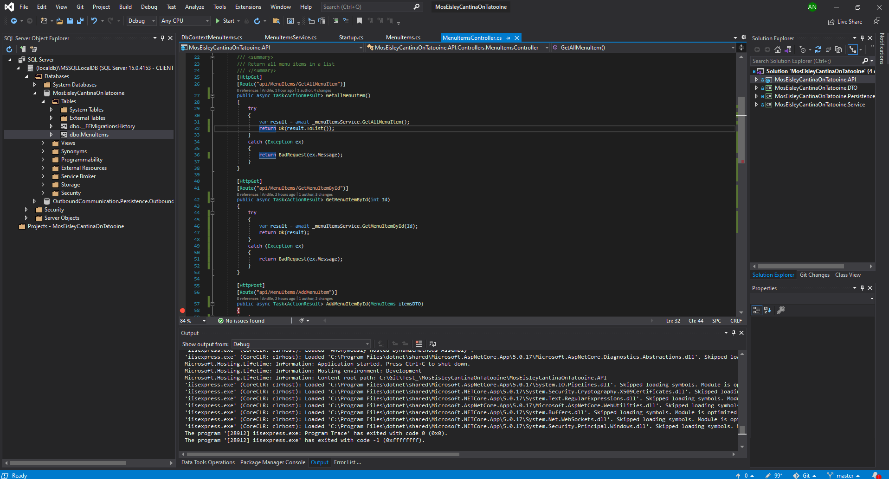

Below is diagram showing the project structure with relations that each project is associated with.

MosEisleyCantinaOnTatooine.API

MosEisleyCantinaOnTatooine.DTO

MosEisleyCantinaOnTatooine.Service

MosEisleyCantinaOnTatooine.Persistence

The structure illustrate the flow and dependence the API project depends on both DTO and Service while service depends on DTO and Persistence. This project approach is more efficiency to avoid spaghetti code and none reusable code

**Git hub**

The project is hosted on git hub for source control.

Clone link: https://github.com/andilengubane/MosEisleyCantinaOnTatooine.git

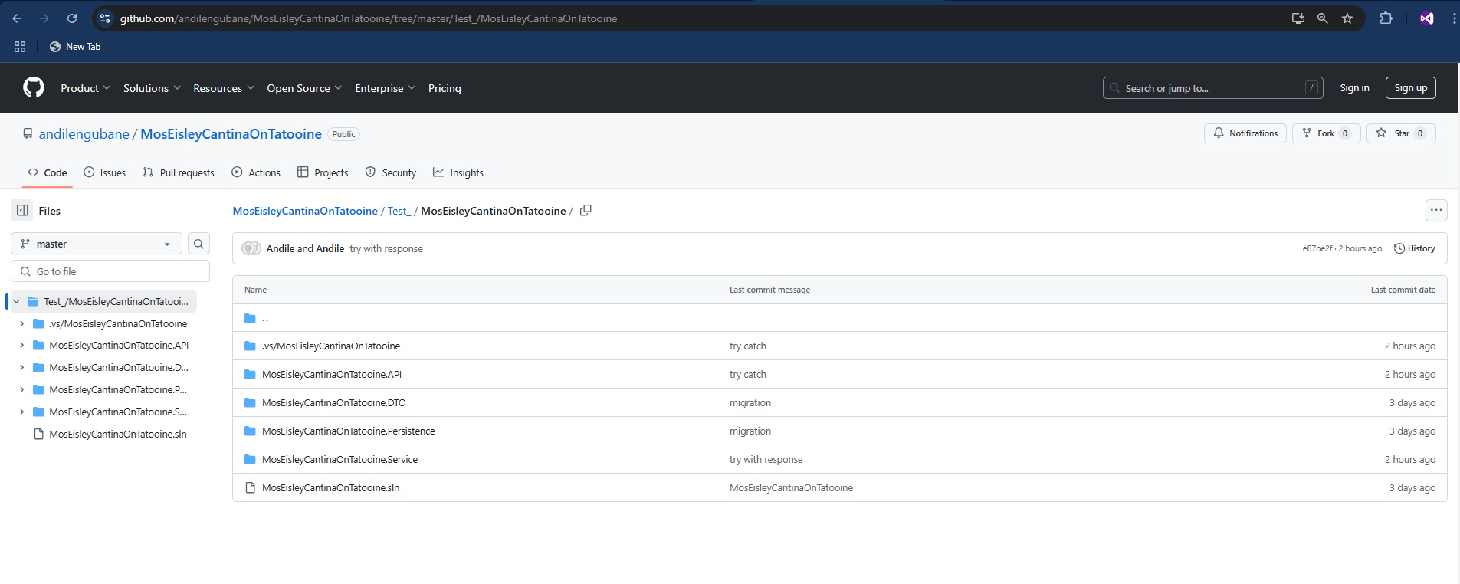

**SQL database script**

Before executing the project as hole you have to run the script and on sql or local database please remember to update connection string to point to your database.

CREATE TABLE [dbo].[MenuItems] (

[Id] INT IDENTITY (1, 1) NOT NULL,

[Name] VARCHAR (255) NOT NULL,

[Description] TEXT NOT NULL,

[Price] DECIMAL (10, 2) NOT NULL,

[Image_Url] VARCHAR (255) NOT NULL,

[CreatedDate] DATETIME DEFAULT (getdate()) NULL,

PRIMARY KEY CLUSTERED ([id] ASC)

);

